Multiple-choice section

|  |  |  |  |  |  |  |  |  |
| --- | --- | --- | --- | --- | --- | --- | --- | --- |
| Question | 1 | 2 | 3 | 4 | 5 | 6 | 7 | 8 |
| Answer | D | A | A | A | C | B | A | D |

Question 1 [6.1]

**D**

60°, 35°

Corresponding angles means that they are equal.

*s* + 20 = 80

*s =* 80 – 20

*s* = 60°

Alternate angles means that they are equal or same.

2*t* + 10 = 80

2*t* = 80 – 10



Question 2 [6.1]

**A**

The sum of interior angles in a triangle add to 180°.

65 + 75 = 140°

180 – 140 = 40°

The third interior angle is 40°.

Therefore *a* = 140° (straight line 180°)

Question 3 [6.2]

**A**

Triangles *A* and *B* are congruent by ASA.

Question 4 [6.4]

**A**



Question 5 [6.3]

**C**

The co-interior angles within a parallelogram add to 180°.

Question 6 [6.7]

**B**

A pentagonal prism contains 10 vertices, 7 faces and 15 edges.

Question 7 [6.7]

**A**

A *prism* is a solid with two identical polygon ends and a uniform cross-section.

Question 8 [6.4]

**D**

*A*′*B*′ = 0.5 × 1.6 = 0.8 cm

Multiple-choice total marks: 8

Short answer section

Question 9 3 marks [6.3]

|  |  |
| --- | --- |
| **(a)** Quadrilateral  3*x* + 4*x* + 2*x* + 90° = 360° (sum of angles of a quadrilateral is 360°)  9*x* = 360° – 90°  9*x* = 270°  *x* = 30° | **(b)** Parallelogram  2*y* + 3*y* = 180°  (co-interior angles in parallel lines add up to 180°)  5*y* = 180°  *y* = 36°  *z* = 2*y*°  (opposite angles of a parallelogram are equal)  *z* = 72° |

**(c)** The sum of interior angles in a pentagon is 540°, therefore each angle is equal to (540 ÷ 5 = 108°)

108 = 4*x* + 12

108 – 12 = 4*x*

96 =4*x*

= *x*

*x* = 24°

Question 10 6 marks [6.1]

**(a)** *n* = 45° (alternate angles in parallel lines)

180 – 145 = 35°

Therefore *m* = 35° (alternate angles)

The missing angle in the triangle is:

180 – *n* – 35 = 100°

*p* = 80° (supplementary angle)

|  |  |
| --- | --- |
| **(b)**  C:\Users\Maja\AppData\Local\Microsoft\Windows\INetCache\Content.Word\PM2e_09_EB_06_SATS_01.jpg  By drawing alternate angles:  alternate angle = 35°  co-interior angle = 60°  35° +60° = 95° |  |
| **(c)** |  |

By considering the co-interior angles:



Angles 3*e* and *d* are alternate and are therefore equal.



Angle *f* is co-interior to 50°, which means *f* = 180 – 50 = 130°.

Question 11 3 marks [6.1]

|  |  |
| --- | --- |
| **(a)**  C:\Users\Maja\AppData\Local\Microsoft\Windows\INetCache\Content.Word\PM2e_09_EB_06_SATS_02.jpg | A straight angle is made from the sum of the angles: |
| **(b)**  C:\Users\Maja\AppData\Local\Microsoft\Windows\INetCache\Content.Word\PM2e_09_EB_06_SATS_03.jpg | The angles are co-interior and therefore add to 180°. |
| **(c)** | The two angles are co-interior.  Therefore:    Given that *x* = 30° and *y* = 40° the equation becomes: |

Question 12 5 marks [6.2]

In ∆*KLM* and ∆*VWM*,

∠*LKM* = ∠*MVW* (alternate angles, *KL* || *WV*)

∠*KML* = ∠*VMW* (vertically opposite angles)

*KL* = *WV* (given)

∴ ∆*KLM* ≡ ∆*VWM* (ASA)

∴ *LM* = *MW* (matching sides of congruent triangles)

Question 13 2 marks [6.6]

|  |  |
| --- | --- |
| C:\Users\Maja\AppData\Local\Microsoft\Windows\INetCache\Content.Word\PM2e_09_EB_06_SAT_07.jpg |  |

Question 14 8 marks [6.1,6.5,6.6]

|  |  |  |  |  |  |
| --- | --- | --- | --- | --- | --- |
| **(a)**  ACPM9_PR_6_14tsa | | *c* = 100° (corresponding angles)  *b* = 80° (*b* and *c* form a straight angle)  *a* = 180 – 80 – 80 = 20° (*a* is the top of the isosceles triangle, with two 80° angles at the base) | | | |
| **(b)** | | | ∆*RPQ* = ∆*RST*  *R* is common  *RPQ* = *RST*    *x*(*x* + 2) = 24 | | | |
| **(c)** | | | |  | | | |
| **(d)** | 2s = 60° 4t = 60° | | | |

Question 15 3 marks [6.7]

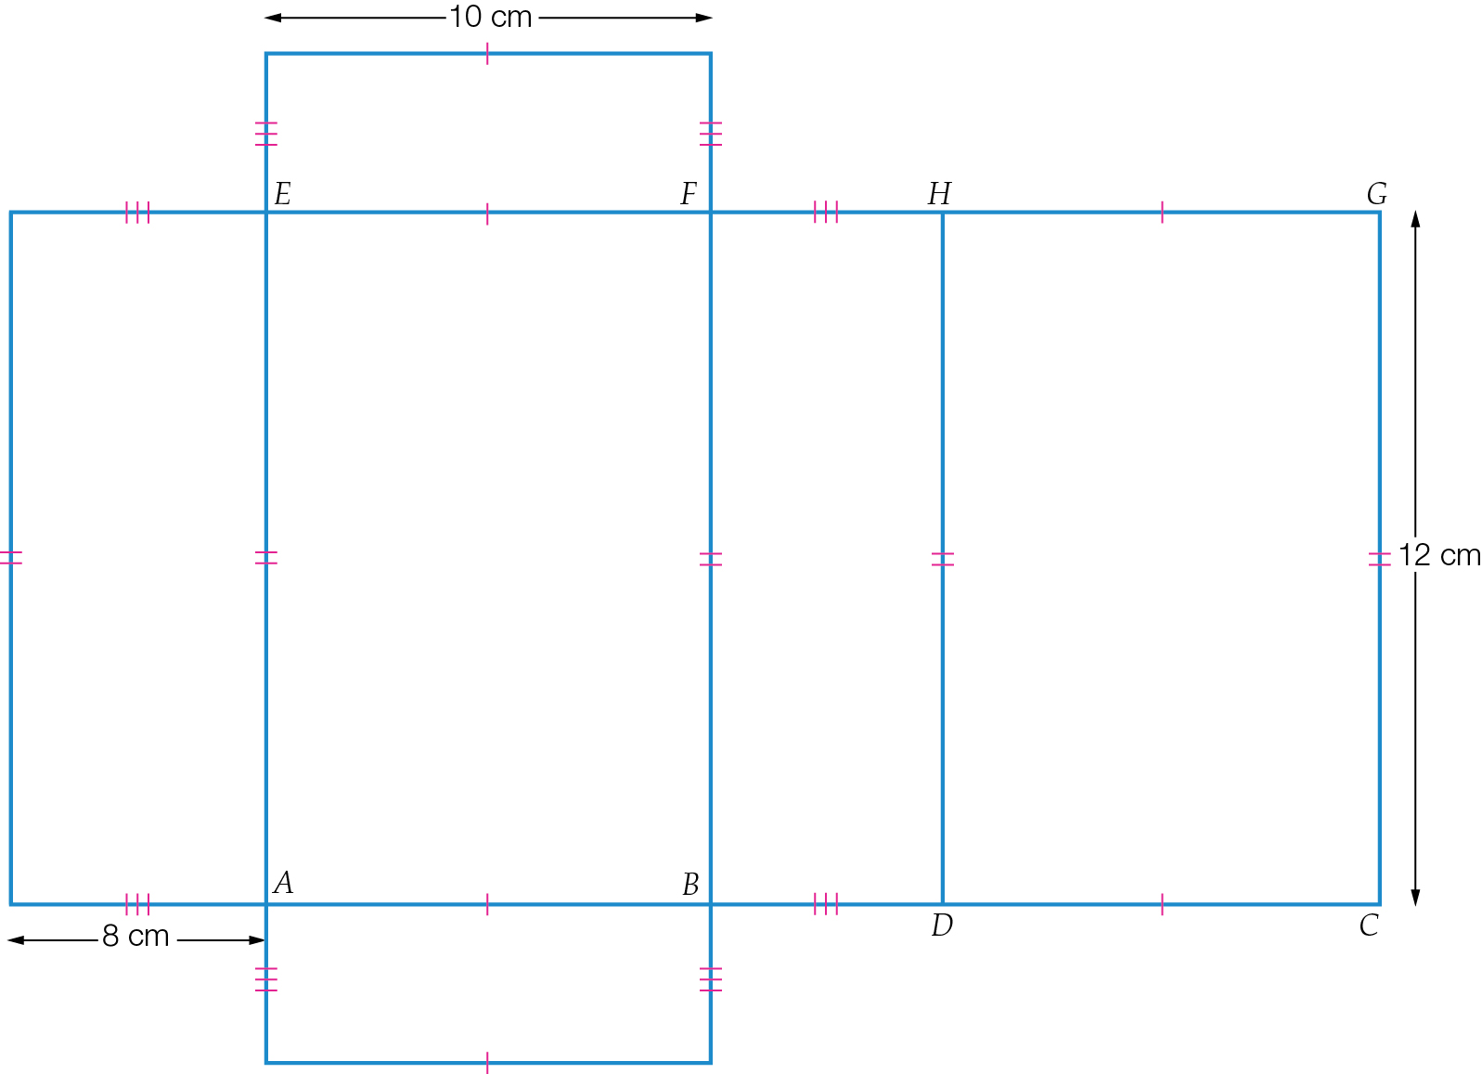

Question 16 2 marks [6.6]

By drawing the triangles separately, we can see that they are similar by AAA.

The angles marked are vertically opposite and are therefore equal.

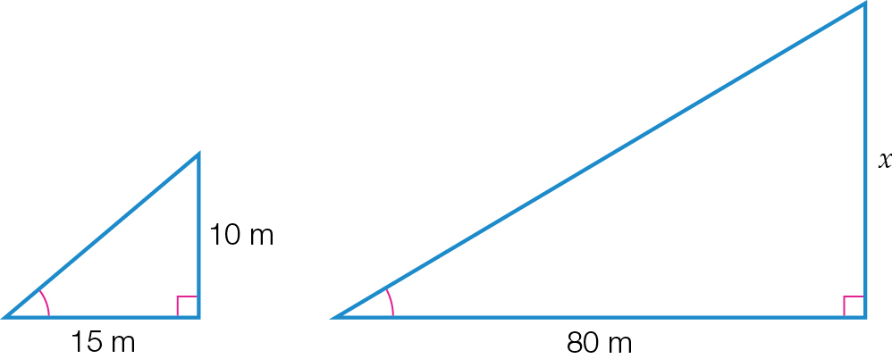



The width of the river is 53.3 m.

Question 17 5 marks [6.5]

**(a)** ∠*BAC* = 90° (angle sum of triangle)

∠*EDF* = 38° (angle sum of triangle)

In ∆*ABC* and ∆*DEF*,

∠*BAC* = ∠*DEF* = 90°

∠*ABC* = ∠*DFE* = 53° (given)

∠*ACB* = ∠*EDF* = 37°

∴ ∆*ABC* ||| ∆*EFD* (AAA)

**(b)**  (matching sides of similar triangles are proportional)



*x* = 6 cm

 (matching sides of similar triangles are proportional)



*y* = 4 cm

Question 18 2 marks [6.4]

**(a)** side of small square = 1 cm

side of large square = 1.5 cm

scale factor = 1.5 ÷ 1 = 1.5

**(b)** scale factor = 1 ÷ 1.5 = 

Question 19 4 marks [6.6]

In ∆*PQR* and ∆*STR*

∠*PRQ* = ∠*SRT* (common angle)

∠*PQR* = ∠*STR* = 90° (given)

∠*RST* = ∠*RPQ* (angle sum of triangle)

∴ ∆*PQR* ||| ∆*STR* (AAA)



 (matching sides of similar triangles are proportional)

*z* = 6.4 cm

Question 20 3 marks [6.2]

In ∆*DEH* and ∆*GFH*

∠*DEH* = ∠*GFH* (alternate angles, *DE* || *FG*)

∠*EHD* = ∠*FHG* (vertically opposite angles)

*DE* = *FG* (14 cm, given)

∴ ∆*DEH* ≡ ∆*GFH* (ASA)

∴ *x* = 8 cm (matching sides of congruent triangles)

Question 21 3 marks [6.5]

**(a)** scale factor = 5 ÷ 10 = 0.5

**(b)**

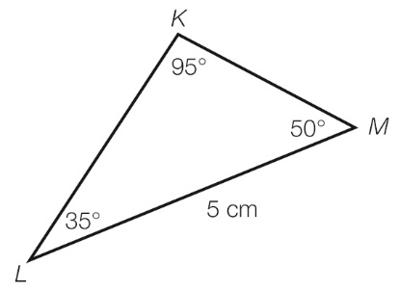

Question 22 1 mark [6.4]

Scale factor = 

New area = 

Short answer total marks: 50

Extended answer section

Question 23 9 marks [6.5]

**(a)** *ABC* = 105° (angle sum of triangle)

**∠***CAD* = 30° (angle sum of triangle)

In ∆*ABC* and ∆*CDA*

**∠***BAC* = ∠*ACD* = 45° (given)

∠*ABC* = ∠*CDA* = 105°

∠*BCA* = ∠*DAC* = 30°

∴ ∆*ABC* ||| ∆*CDA* (AAA)

**(b)** *AC* is a common side, so:

In ∆*ABC* and ∆*CDA*

**∠***BAC* = ∠*ACD* = 45° (given)

∠*ABC* = ∠*CDA* = 105°

*AC* is a common side

∴ ∆*ABC* ≡ ∆*CDA* (ASA)

**(c)** ∠*BAC* = ∠*DCA* = 45°

These are a pair of alternate angles contained between *AB* and *DC*, hence *AB* || *DC*.

∠*DAC* = ∠*BCA* = 30°

These are a pair of alternate angles contained between *AD* and *BC*, hence *AD* || *BC*.

**(d)** *ABCD* is a parallelogram as it has both pairs of opposite sides parallel (also equal from congruent triangles).

Question 24 2 marks [6.6]

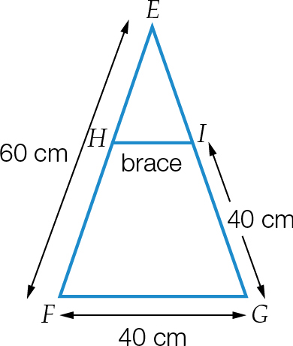

∆*EFG*  ∆*EHI* are similar triangles.

∠*E* is common

 

Therefore ∆*EFG*  ∆*EHI*



Extended answer total marks: 11

TOTAL test marks: 69